Your Name
Novel Project
15 April 2020
Novel: Educated
Length: 329 pages
Title Significance: The title of the novel is significant in that Westover’s formal education didn’t begin until her brother left for college. Her family was a Mormon family and they lived what modern society would consider “off the grid.” She had never gone to public school because her father feared the government. For most of her childhood she saw school as tool the government used to control its citizens; it wasn’t until her older brother declared he was leaving the family’s lifestyle for college, Tara realized the world was much wider and possibly different than her parents had led her to believe.
Quotes:
- Westover gives an early image of her father on page 4, “My father was not a tall man but he was able to command a room. He had a presence about him, the solemnity of an oracle. His hands were thick and leathery – the hands of a man who’d been hard at work all his life – and they grasped the Bible firmly.” Her own tone toward him is one of affection and respect.
- Later in the book, her tone changes because she has now grown, “Dad lived in fear of time. He felt it stalking him” (Westover 55). The reverence she once had for him has gone at this point and her tone grows more skeptical as she grows.
Review: *****
I would give Educated five stars as it kept me interested the entire time. Westover's childhood was much different than my own. I had parents who doted on me and both had jobs (usually two or three at once) so that we could afford to live in a nice development. The only thing I would caution readers on is the structure of the book. It's told as memories and therefore doesn't follow a complete linear fashion. Westover sometimes takes a detour into another memory instead of finishing the first. They all do tie together nicely, but some readers may find the detours difficult to follow and then get lost.
Character Related Assignment – Gender
In the memoir Educated, the author often discerns how her gender as female sets her apart in her family and her religion. From early on in the book, Westover is given the “rules” of what is expected from a female in her family and her religion. Her brothers were allowed to leave their mountain home without much of a fuss from their parents. It was almost expected that they would strike out and make their own way in the world. However, Tara was always expected to follow in her mother’s footsteps as a house wife and midwife/healer. She endured physical and psychological abuse from her father and her brother Shawn, both wanted to keep her subservient like her mother. It was her brother Tyler who emphasized the importance of education and leaving the mountain:
“Have you thought about leaving?” Tyler asked.
“And go where?”
“School,” he said.
“It’s time to go, Tara,” Tyler said. “The longer you stay, the less likely you will ever leave.”
“You think I need to leave?”
“I think this is the worst possible place for you…go where I went, go to college” (120).
If Tyler hadn’t continuously reinforced the potential Tara had, as well as the way her father and brother were smothering it, life would have been very dismal indeed.
The second stifling influence on gender throughout is the Mormon religion. In the Mormon religion, polygamy is allowed and encouraged. The patriarchal structure of the religion allows for men to have many wives; the more affluent or important the man, the more wives he has. Even after Tara has enrolled at BYU (Brigham Young University), she questions the role of gender in her faith:
“The number of my sister-wives would depend on my husband’s righteousness: the more nobly he lived, the more wives he would be given…For as long as I could remember, this image had been at the core of my idea of paradise: my husband, and his wives.” There was a sting in this arithmetic: in knowing that in the divine calculus of heaven, one man could balance the equation for countless women” (245).
Even though she had escaped her family and their hold on who she should be, Westover had yet to escape her faith and its hold on gender roles. By the end of the book, Westover changed her provincial perception on education which was reinforced by years of ignoble teaching from her father. She even somewhat changed her straitlaced view on her religion throughout college. Her gender role in her faith however, was ingrained very deep and would probably take the rest of her life.
Setting – Map
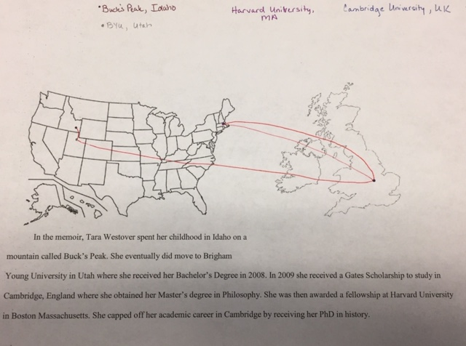
Plot - Conflicts
Westover encounters two major conflicts in her memoir. The first is an internal conflict of faith. Her faith dictates a set of standards and morals that differs from much of mainstream society. Her ultimate decision to allow education into her life and go against the tenets of Mormonism which set forth that she be a part of polygamy and a patriarchal society cause another the external conflict in her life. At one point another Mormon student at BYU asks her if she believes people should study church history, she answers that she does. His response that “’Many women struggle with their faith after they learn about polygamy’” (Westover 244) explains the dichotomy of Westover as a member of the Mormon faith and Westover as the academic she is evolving into. Once she has crossed the line into academia, she no longer studies religion as a church member, instead she is studying it as a historian.
The second major conflict is an external one of man v. woman. Once she leaves Buck’s Peak for BYU, she no longer adheres to the strict patriarchal pattern her father has set forth her entire childhood. She has her own thoughts about what she is capable of and who she wants to become. Her father however still holds onto the belief that she will simply walk back into her mother’s kitchen or stillroom. “’Well look at that, back from England and in the kitchen where you belong’” (250). In a religion that places men above women, and a household that adheres to such ideas, Westover finally found the strength to stand up for herself as an individual. She overcame her father’s paranoia and educated herself.
Theme
The premise of theme is to encapsulate the author’s main idea. Westover has two major themes working together in her memoir. The first is that of knowledge v. ignorance. Her academic knowledge didn’t begin until she left Buck’s Peak and entered the lecture halls of BYU. Ironically, her social knowledge of the way the world worked began there also. For instance, Westover had no idea what had truly happened in the Holocaust:
“I suppose I was in shock, but whether it was the shock of learning about something horrific, or the shock of learning about my own ignorance, I’m not sure…I’d thought it was a small conflict, like the Boston Massacre…to have misunderstood it on this scale-five versus six million – seemed impossible” (157-158).
This faux pas was made in a class on Western art. She had opened her text book and seen a picture but couldn’t decipher the word under it that stated “Holocaust.” She raised her hand and ask the professor what that word meant. The professor treated it like she was making a sick joke and ignored her and moved on. After class, the only friend she had at this point informed her “’You shouldn’t make fun of that. It’s not a joke’” (157). Unfortunately, most of her freshman and sophomore year was spent in this manner, gaining social and academic knowledge by trial and error.
This example and many more like it led to the theme of isolation. Westover is isolated from the world for the first part of her life. He father’s fear of the government and its control caused her to rarely leave her home on Buck’s Peak.
“…around the time he turned thirty, Dad pulled my brothers out of school…In the four years that followed, Dad got rid of the telephone…he stopped registering and insuring the family car. Then he began to hoard food…Dad had just turned forty when the Feds laid siege to the Weavers, an event that confirmed his worst fears” (29).
This isolation lasted until Westover went into town and found herself her first job off the mountain and away from her father’s junkyard. She joined a theater group and church choir but still never really fit in either of those places. The first time she ever felt she was truly home was in Cambridge, England. “My friends in Cambridge had become a kind of family, and I felt a sense of belonging with them that, for many years, had been absent on Buck’s Peak” (280). Although she does travel to Idaho many times after this, academia had won her heart and her mind and provided the stability Buck’s Peak and her father never could.

